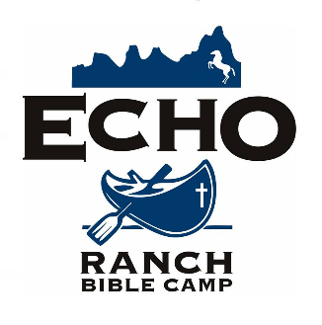
Summer Staff Information Packet

Thanks for your interest in serving with us this summer at Echo Ranch Bible camp! Hopefully the information in these pages will give you a clearer understanding of what a summer at Echo Ranch is like and answer some of the questions that are in your mind.
If you have more questions, please don’t hesitate to contact us! We would love to talk with you, and together discern whether ERBC is the right place for you to spend your summer.

Here’s how to reach us:

Email: EchoRanchRecruitment@avmi.org
Phone: 907-789-3777
Facebook: /EchoRanchBibleCamp
Instagram: @EchoRanchAK

Life at Echo Ranch
Written by Jon-Michael Gwinnell, former program director
and Grant Werthman, activities coordinator
There is something about Alaska. Talk to anyone about this beautiful state and their eyes light up. Watch the Travel Channel long enough and you are bound to catch at least one show about Alaska. Stories have been written and movies have been made all with the 49th state as the stunning backdrop. Have you ever wanted to travel to Alaska? If you’re like most people, you probably need a good excuse. What if you could enjoy the beauty of Alaska and serve the Lord by sharing the Gospel at the same time? Echo Ranch Bible Camp is a great place to spend your summer doing ministry, and it just so happens to be nestled in the backcountry of southeast Alaska. Don’t let the “wilderness” or “remote camp” part scare you; Echo Ranch combines the comforts and safety of modern amenities with the fun and adventure of Alaskan nature.
Echo Ranch is like a little city with a population that swells and shrinks from week to week as campers and guests come and go. The camp is powered by diesel generators that run 24 hours per day. Our well system provides plenty of running water to our kitchen, showers, and washers and dryers for doing laundry. Wonderful meals are prepared three times a day with plenty of leftovers for a midnight snack. Food is brought into camp from town twice a week so the produce is always fresh – we even boast “Juneau’s finest salad bar” at every meal, for those conscious of eating healthy. Wifi is available on the weekends for checking email and Facebook. Sorry, no cell service at camp, but you’ll get the chance to go into town a few times a summer to call family, and at camp, you’ll be so caught up in the community that you won’t miss having service.
Our chapel, constructed in 2018, has a video projector and a new sound system. Chapel takes place twice a day for campers, the central focus of the camp schedule where the Gospel is clearly preached. Do you have musical abilities? We could always use people to help sing, play guitar, drums, and piano. On Sundays we have church at camp and any staff member is welcome to be a part of the worship team.
Like to work out? In the gym there is a small but well-equipped exercise room for staff, with a squat rack, benches, dumbbells, deadlift platform, and more. Going for a run is easy, follow the path that runs around the camp. Echo Ranch’s large sports field is one of the nicest pieces of flat grassland in Juneau, Alaska, where level ground is hard to come by; it’s here that we play field games like Storm the Castle and Pirates vs. Ninjas. These games are highlights of the week for many campers, and we play them rain or shine (because we do get quite a bit of rain here). Counselors often play games on their own during the weekends when campers aren’t present – ultimate frisbee, volleyball, basketball, frisbee golf, and soccer are all popular options that camp has all the equipment for. On our front beach, we have canoes and paddleboards available for use, and on hot days, the brave can even go for a swim in the ocean (which stays forty degrees year-round – it’s aggressively refreshing)! On the less sporty side of recreation, board games, puzzles, and the occasional movie are also popular pastimes on weekends, as well as just hanging out and getting to know the other cool people from around the country who have come to serve at camp.
The ”ranch” part of our name comes from our herd of around twenty horses, a major draw for campers and retreaters. Our wranglers take care of and train this herd to give rides to kids of all ages, but summer staff can count on a couple chances throughout the summer to go on a trail ride, too.
We host nine weeks of camp per summer for kids from ages 7 to 18, bringing in a different age group each week and averaging around 100 campers per week. Counselors are paired with a different co-counselor each week and spend the week with their 7-10 campers playing games, doing activities, going to chapel, and leading discussions to build relationships and share the Gospel with them. It’s a little intimidating at first, but that’s why we have two weeks of orientation before we start camp, and why we have head counselors for the guys and the girls whose job is to help, advise, and disciple each counselor. All our summer staff are also matched up with a full-time staff member to be their mentor for the summer, helping them to grow spiritually and process all that they’re experiencing. You’ll never be left to figure things out all on your own.
In the middle of the summer we have a Sabbath week where we take a week off from camp to rest, have some fun, and focus on our own spiritual refreshment so we can be prepared to go back to ministering. We’ll do a number of optional hikes – ranging from a short walk in the woods to literally climbing a mountain – for those eager to immerse themselves in the Alaskan wilderness. Community is huge for us at camp, and so we also tend to plan fun events like laser tag games, a hilarious group photo scavenger hunt, a skit night, Olympics-style competitions, and more.
Don’t be fooled, it’s still Alaska. Surrounding Echo Ranch are snowcapped mountains, a stream with running salmon (oh yeah - you’ll be in heaven if you like to fish), a beach front where whales and sea lions can be seen. Bald eagles and porcupines are a common sight. By midsummer, the days start in the wee hours of the morning and last until almost midnight, with gorgeous sunsets drawn out over an hour. Waterfalls, glaciers, and halibut fishing are within your reach. And the best part of it all is that everything we do at Echo Ranch revolves around kids coming to trust in Christ as their Savior. What better reason to come to Alaska?

“I don’t remember what was going through my mind that made me come to Alaska this summer but it was more than worth it. I saw God in how He worked in the hearts of staff and campers, in nature, in the fun and not-so-fun moments, and in my own weakness. I’ll never forget this summer!” – Peter (2021-22 counselor)

“At Echo Ranch, God really taught me how to put Him first, how to truly love others more than myself, what it means to be in community with others, how to just sit in His creation and listen, how to be open about my story to grow and help others, and so many more things!” – Brie (2021 kitchen staff)

“At camp, God taught me the power of prayer and how He truly does work through us and provide for us, sometimes in ways that we can’t even imagine. He is so good to us, all we have to do is ask.” – Karlie (2022 wrangler)

Summer Staff Qualifications:
Spiritual Life
Staff must give clear evidence of faith in Jesus Christ as Lord and Savior, have a practice of personal Bible study and prayer, and demonstrate dedication and spiritual maturity by a daily walk of faith and obedience.
They must be able to subscribe to the Doctrinal Statement of Avant and must be prepared to lay no undue emphasis upon doctrines or religious practices not covered by the Doctrinal Statement. Avant Ministries holds and teaches a non-charismatic position regarding the modern-day manifestation of spiritual gifts.
Church Affiliation
Avant is solidly committed to the New Testament emphasis on local assemblies of believers as well as the universal Body of Christ. Since the Avant goal is the establishment and development of local churches in every field of its activity, we ask that all volunteers be functional members of a local church.
Health
Volunteers must be in good physical health and are required to have health insurance. They must sign a
responsibility waiver and release to obtain medical care and list an emergency contact.
Attitudes and Personal Habits
It is essential that volunteers be able to work happily with others and that they be willing to follow the leadership of those whom Echo Ranch and the Lord has placed over them.
They must be able to adjust to new situations, meet trials with patience, perform assigned duties willingly and
demonstrate humility, tact and wisdom in their relationships with others. Volunteers should exercise moderation and be sensitive to local standards in the areas of dress, grooming and personal habits. Above all, volunteers should be willing to grow and let the Lord work through them.
Financial Support
Volunteers are responsible for raising funds for their missionary work by presenting their needs to churches, church groups and individuals.
Camper Safety
It is important that we create a safe environment for our campers, an environment that protects those you serve from abuse. Any verbal or nonverbal sexual behavior with any camper or other child is totally inappropriate and unacceptable. All volunteers will be required to complete a background check consent form and an online abuse prevention training course prior to coming to camp. Speakers, Work Team leaders and Ministry Team leaders and team members will also be required to complete an online course on child safety. We request that any knowledge or suspicion of any adult having an inappropriate relationship with a camper or other child be reported promptly to the leadership. If the person in question is the leader, the report should be made to the supervisor of that person.

Sample Daily Camp Schedule
The schedule varies depending on the age group and day-to-day changes, but here’s a sample of what a normal camp day tends to look like:
8:00 Breakfast
8:45 Cabin Clean Up Competition
9:30 Morning Field Game – counselors do group devos and get time off while campers play a game
10:30 Morning Chapel, followed by cabin discussions
12:00 Lunch
1:00 - 5:15 Camp Activities - including horse rides, zip line, canoeing, group games, arts & crafts, skills classes, and more! Depending on the age group, campers may have some amount of free time, but there will also be times for cabin activities or whole-camp activities and competitions
5:30 Dinner
6:30 Evening Field Game – this time, everyone plays!
7:30 Evening Chapel
9:00 Evening Activity – including campfire, skit night, night game, etc., depending on age group
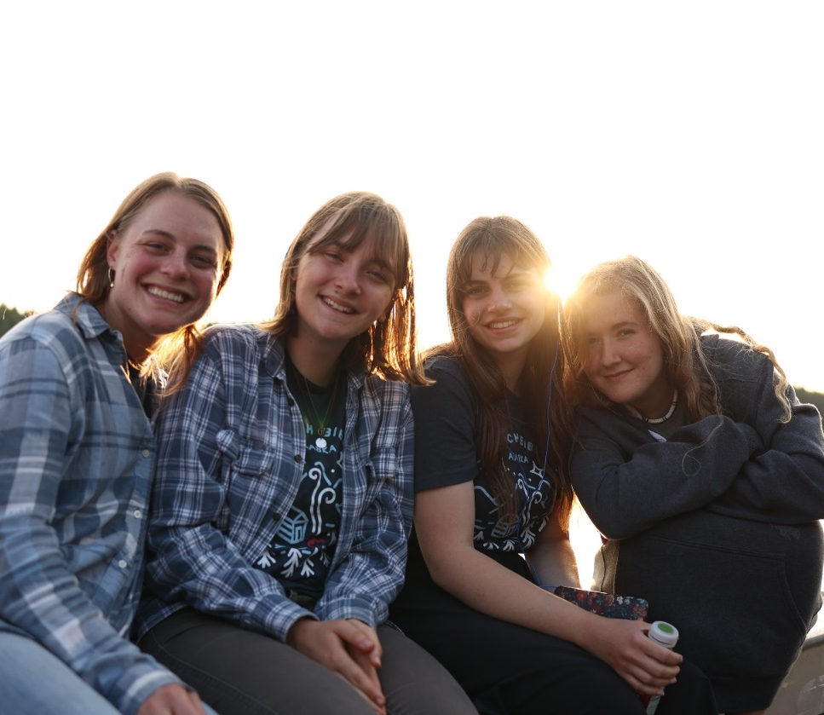
9:30 or Later Bedtime – our youngest campers tend to be in bed by 9:30 or 10:00, while older age groups often stay up late hanging out with their cabinmates and counselors.

Summer Staff FAQ’s

What will my responsibilities be?
In summary, counselors are responsible for ensuring that campers ages 7-18 have a fun and safe time at camp, while sharing with them the love of Christ in both word and deed. It’s one of the most fun and rewarding summer jobs there is!
Your responsibilities when you are counseling will include staying in a cabin during the camp week (i.e., Monday through Thursday, Friday, or Saturday, depending on the age group that week) with 7-10 campers and 1 co-counselor; doing activities with campers throughout the day; attending chapels with campers and leading discussions after each chapel; participating in field games and other whole-camp activities; leading free time activity stations for certain age groups; teaching skills classes for certain age groups; supervising your campers and making sure they are staying safe, especially during “high risk” times like when they are getting ready for bed; and more. It sounds like a lot, but we will thoroughly train you for all of it (even for things like leading cabin discussions) during our two-week orientation at the beginning of the summer.
You likely won’t counsel every week of camp, though; you can count on occasionally being assigned to what we call workstaff. This role, usually assigned to 4-8 summer staff per week, is an essential role that is no less a part of ministry than counseling. It entails helping with support services like serving meals, doing dishes after each meal, cleaning bathhouses and other areas of camp, and helping keep the summer staff dorms clean and tidy. There’s more opportunity for rest and alone time in the workstaff schedule than the counseling schedule, meaning it can be a much-needed emotional and spiritual break between weeks being a counselor. It can also be a lot of fun, as you get to hang out with and do daily devos with the other workstaff, and you still get plenty of interaction with campers as you’ll continue to help run free time stations and play field games with them.
Responsibilities of Wranglers, Kitchen and Maintenance Assistants, etc. vary depending on the department in which they are working. If you’d like more specific details on these roles, send us an email at EchoRanchRecruitment@avmi.org .
Wait - I'm not getting paid!?
That’s right – in fact, no one at Echo Ranch gets paid. All of our full-time staff are full-time missionaries with Avant Ministries and raise support from churches and individuals to work at camp. All of our summer staff and volunteers likewise raise support to come serve at camp. This allows us to keep costs down for campers from many different backgrounds. Our camp fees are very low compared to many other camps across the country, and the reason we can do this is because our staff are committed to raising their financial support.

Don’t consider this a summer job; consider it a summer missions opportunity. Part of missions is doing whatever it takes to reach people for the gospel. We know that giving up a summer job is not easy. But once you begin to see the impact you will have on the campers and what God will do through you and in you at camp, you’ll see that the benefits far outweigh the sacrifice of a few months of earning money.

If you’re committed to coming to Echo Ranch, we want to come alongside you and help you raise support. When you start your application and get in touch with us, we’ll help you navigate the support raising journey.
How do I raise support? And how much do I need to raise?
Tell people that you're passionate about serving in Alaska. Inform your family, friends, church, co-workers, about the financial need that you have for this summer. Write letters, send emails, ask for prayer - these are all steps that full-time missionaries must take all the time. The more excitement and energy they see from you, the more they will feel good about supporting your cause.

Our room-and-board fee for summer staff (and full-time staff, in fact) is $500 to help us cover the cost of food, fuel, and other expenses for keeping camp running. If you’re coming from outside of Juneau, you’ll also need to raise the cost of your plane ticket, which tends to cost $600-$1000, depending on when you book and other factors.

That means you’ll need to raise a minimum of $1100 to come serve for the summer. It might sound like a lot to you, but consider that many missions opportunities can be double or triple this cost for a small fraction of the time you’ll spend at camp. Furthermore, God is fully capable of providing you with all the funds you need if you take step of faith and trust Him to act.

What’s the weather like in Southeast Alaska? Can I go hiking/fishing/etc?

Summer weather in SE Alaska will often feel much like spring or fall in many areas of the U.S., with temperatures averaging in the low-to-mid 60s. We do get some hot and sunny days, though – you can experience a wide range of temperatures in just a week’s time! Juneau is situated on the edge of the Tongass Rainforest, so we get plenty of drizzly rain throughout the year. A good rain jacket and boots are a must! But on the clear days, with summer wildflowers blooming and the sun shining on the scenic Chilkat Mountains on the horizon, you’ll have no doubt that this is one of the most gorgeous places in the world.

There will be ample time for hiking, fishing, and exploring your surroundings on the weekends and during our Sabbath Week, when you don’t have other responsibilities. Camp is surrounded by acres and acres of wild beauty to explore, and we’ll plan hikes and excursions throughout the summer to give you a chance to immerse yourself in Alaskan nature.

Do I have to come for the whole summer?

Yes, we ask that you commit for the full camp season – from orientation in mid-May through debrief in early August. Our family of staff live, work, eat, and play together as a big family! In order to maintain a healthy, cohesive team, it’s important for everyone to be committed and consistent. Missing out on the crucial times of orientation at the beginning of the season or end-of-summer debrief would be a huge detriment to you socially, mentally, and spiritually.

While we urge you to pray about committing to the full summer, if you have irreconcilable prior commitments (for example, your high school or college graduation or your best friend’s wedding), please talk with us about it and we will try to arrange something that works. Likewise, if an emergency comes up during the summer, such as a health issue or a death in the family, we will help you make arrangements to return home if necessary.

How is the food at camp?

In a word – delicious! Our kitchen staff work hard to prepare three meals a day from scratch. We have what is known around town as “the best salad bar in Juneau,” with lettuce from our garden, veggies cut fresh every day, and homemade dressings. There tend to be plenty of leftover desserts, breads, and snacks that get put on the “free corner,” a space where you can get food any time between meals that you’re hungry. The cooks are also experienced at accommodating preexisting dietary needs and allergies. The meals during the camp week could definitely be described as “camp fare,” with menus commonly including fare like chicken nuggets, spaghetti, tacos, pizza, pancakes, breakfast burritos, etc., but on the weekends we give the cooks time off and our staff and summer staff (including you!) take turns preparing meals, and get the chance to diverge from the typical menus and make favorites from home or try new dishes. It’s always a lot of fun cooking together, and this system has produced some delicious and out-of-the-ordinary meals like chicken and waffles, carbonara, fried chicken, phở, curry, and beyond!
You’ll get the chance to go to town a couple times a summer to buy your own snacks to have on hand, and you can always give a request to our staff who shop for groceries if you need something urgently. The Trading Post (our camp store) also sells snacks and drinks in addition to camp merchandise.

What are the Covid-19 policies? Are staff required to be vaccinated?

Echo Ranch has a Covid-19 Mitigation Plan and remains in cooperation with the City of Juneau and the Health Department. We do not require vaccination against Covid-19, as we believe that to be a personal health choice. Last summer, our policy included testing any staff and volunteers who showed systems indicative of Covid-19 and quarantining anyone who tested positive for 5 days. Our mitigation plan and policies for handling Covid are regularly updated in accordance with city and state mandates and recommendations, meaning that practices and procedures like quarantining, mask wearing, and social distancing can be updated or abolished at any time.

The gist of this, and what you probably want to know, is: you don’t have to be vaccinated to come to camp, but we ask that you be flexible and willing to submit to any policies we need to put in place to mitigate the spread of Covid at camp. It’s impossible to say ahead of time what the Covid situation will look like next summer, but it likely won’t look any different from what you encounter day-to-day at your school, work, or church.

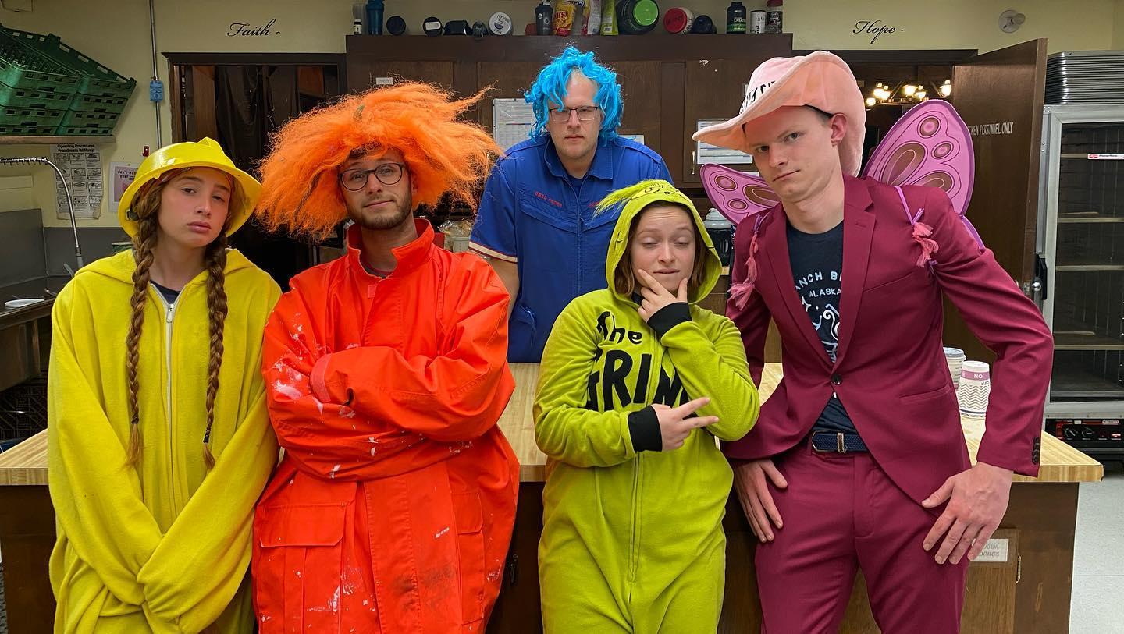
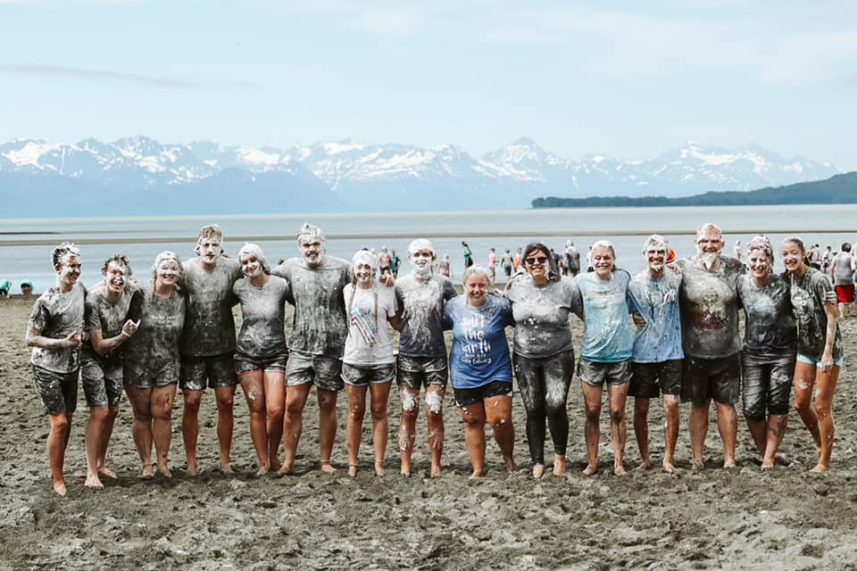
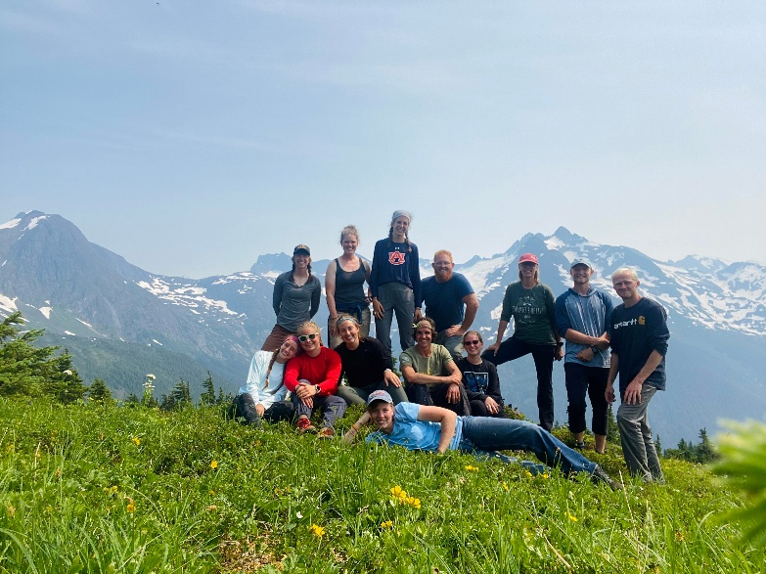
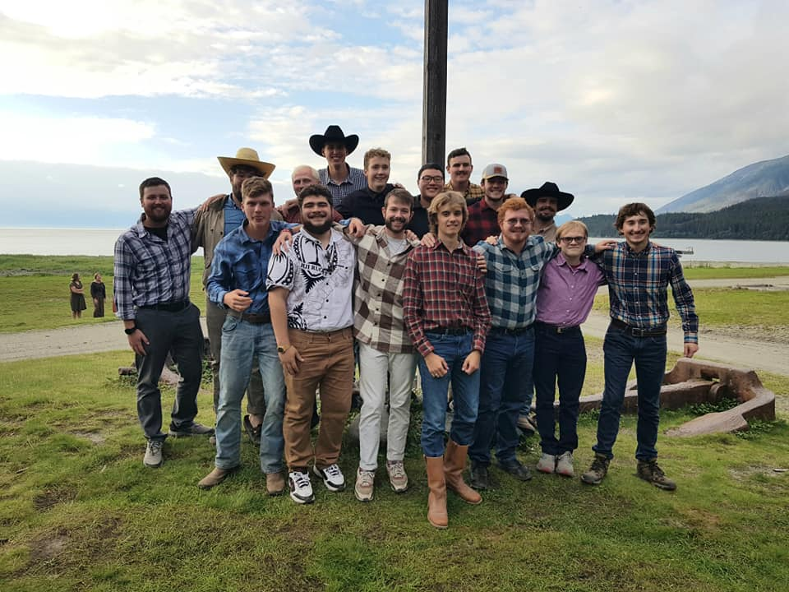
Summer Staff Photo Gallery
